**Name –**T SAMPATH KUMAR

**Registration No –**46238371

**Module Name –** Deep learning

**Develop a machine learning-based fruit classification model using Teachable Machine**

**Aim:**Develop a machine learning-based fruit classification model using Teachable Machine that can accurately identify and classify different types of fruits based on image inputs.

**Requirements:**

Dataset:- <https://www.kaggle.com/datasets/bramar/fruits-classification>

* **Teachable Machine**: https://teachablemachine.withgoogle.com
* A **browser** (preferably Chrome)
* **Internet connection**
* **Unzipping software** (to extract dataset folders)

**Procedure:**

**Step 1**: Download the Dataset

* Visit the Kaggle link and download the fruits classification dataset.
* Extract the ZIP file. You will see folders with images of different fruits like Apples, Bananas, Grapes, etc.

**Step 2:** Open Teachable Machine

* Go to https://teachablemachine.withgoogle.com
* Click “Get Started” → Choose “Image Project” → Select “Standard Image Model”

**Step 3**: Prepare Classes and Upload Images

* Rename the default classes (Class 1, Class 2, etc.) with fruit names such as Apple, Banana, Orange.
* Upload the respective fruit images from the extracted dataset into each class.

**Step 4:** Train the Model

* After uploading, click “Train Model”.
* Optionally adjust training settings like epochs or batch size under Advanced.
* Wait for the model to finish training.

**Step 5:** Test the Model

* Use the webcam or upload test images to check how well the model classifies the fruits.
* The model will display the predicted fruit name along with a confidence score.

**Step 6:** Export the Model

* Click “Export Model”.
* Choose “Upload” (for web-based use) or “Download” (for offline use or integration with TensorFlow or Unity).

**Output:**

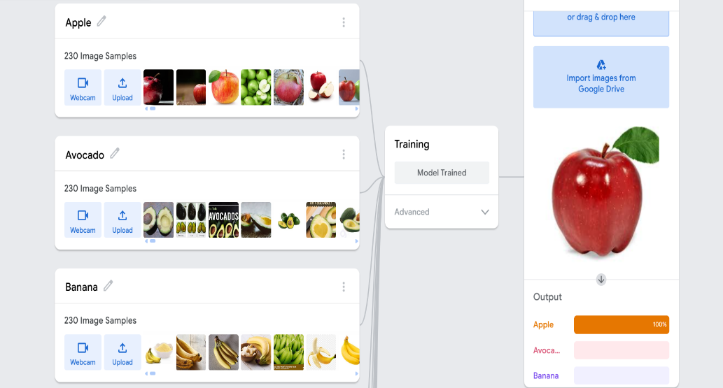

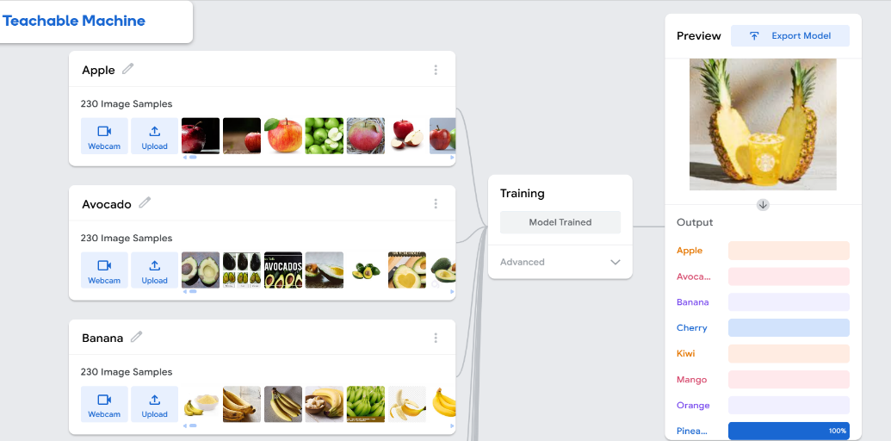

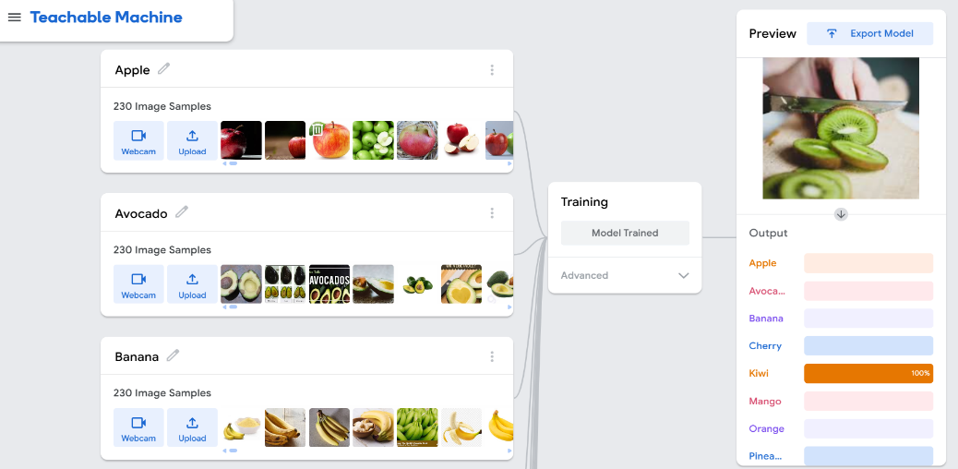

s

